**PRACTICAL – 9**

**AIM:** **Make any logo and 5 PSD( Design) of Home page of website using Adobe Illustrator or Photoshop applying vectors and scalar, Filters etc.**

<!DOCTYPE html>

<html lang="en">

<head>

<meta charset="UTF-8">

<meta name="viewport" content="width=device-width, initial-scale=1.0"> <title>Navigation bar</title>

<style>

body {

margin: 0; padding: 0;

font-family: Arial, sans-serif;

}

.navbar {

display: flex;

width: 100%;

height: 100vh;

background-color: lightgray;

}

.nav-item {

flex: 1;

padding: 10px;

text-align: center;

color: black;

font-weight: bolder;

cursor: pointer;

transition: background-color 0.3s ease;

display: flex;

flex-direction: column;

justify-content: center;

align-items: center;

}

.nav-item img {

max-width: 100%;

max-height: 100%;

/* display: block; */

}

</style>

</head>

<body>

<div class="navbar">

<div class="nav-item">

<img src="ksvlogo.png" alt="Image 1"> <p>ksv logo</p>

</div>

<div class="nav-item">

<img src="logo.png" alt="Image 2"> <p>Vsitr logo</p>

</div>

<div class="nav-item">

<img src="vsitr.jpg" alt="Image 3"> <p> Vsitr</p>

</div>

<div class="nav-item">

<img src="2.jpg" alt="Image 4"> <p> mehsana </p>

</div>

<div class="nav-item">

<img src="city1.jpg" alt="Image 4"> <p> mehsana </p>

</div>

</div>

</body>

</html>

**OUTPUT:**



**PRACTICAL – 10**

**AIM: Create HTML Page with JavaScript which takes Integer number as input and tells whether the number is ODD or EVEN**

<!DOCTYPE html>

<html>

<head>

<title>Odd or Even Checker</title>

</head>

<body>

<h1>Odd or Even Checker</h1>

<label for="numberInput">Enter an Integer:</label>

<input type="number" id="numberInput" />

<button onclick="checkOddOrEven()">Check</button>

<p id="result"></p>

<script>

function checkOddOrEven() {

// Get the input value as a number

const number = parseInt(document.getElementById("numberInput").value);

// Check if the input is a valid number

if (!isNaN(number)) {

if (number % 2 === 0) {

// It's even

document.getElementById("result").textContent = number + " is EVEN.";

} else {

// It's odd

document.getElementById("result").textContent = number + " is ODD.";

}

} else {

// Invalid input

document.getElementById("result").textContent = "Please enter a valid integer.";

}

}

</script>

</body>

</html>

**OUTPUT:**

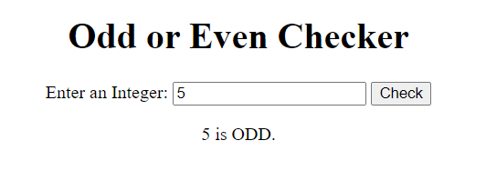

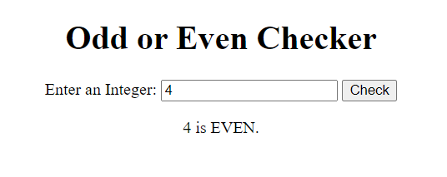

**PRACTICAL – 11**

**AIM: Create HTML Page that contains form with fields Name, Email, Mobile No, Gender, Favourite Color and a button. Also write a JavaScript code to combine and display the information in textbox when the button is clicked.**

<html>

<head>

<title>22BECSE54004 </title>

<style>

body,table{

text-align: center;

}

</style>

<script language="JavaScript">

function showInput() {

document.getElementById('display').innerHTML = document.getElementById("user_name").value;

document.getElementById('display1').innerHTML = document.getElementById("user_email").value;

document.getElementById('display2').innerHTML = document.getElementById("user_password").value;

document.getElementById('display3').innerHTML = document.getElementById("user_mobile").value;

document.getElementById('display4').innerHTML =

document.querySelector('input[name="user_gender"]:checked').value;

document.getElementById('display5').innerHTML = document.getElementById("user_color").value;

}

</script>

</head>

<body>

<table>

<tr>

<td>

<h2> REGISTRATION FORM </h2>

<form>

<b>NAME : <input type="text" id="user_name"></br></br>

EMAIL : <input type="email" id="user_email"></br></br>

PASSWORD : <input type="password" id="user_password"></br></br>

MOBILE NO : <input type="text" id="user_mobile"></br></br>

GENDER : <input type="radio" name="user_gender" id="user_gender" value="male" /> male

<input type="radio" name="user_gender" id="user_gender" value="female" /> female</br></br>

FAVOURITE COLOUR : <input type="text" id="user_color"></br></br></b>

</form>

<input type="submit" onclick="showInput();"><br />

<label>Your input is:</label>

<p><span id='display'></span></p>

<p><span id='display1'></span></p>

<p><span id='display2'></span></p>

<p><span id='display3'></span></p>

<p><span id='display4'></span></p>

<p><span id='display5'></span></p>

</td>

</tr>

</table>

</body>

</html>

**OUTPUT:**

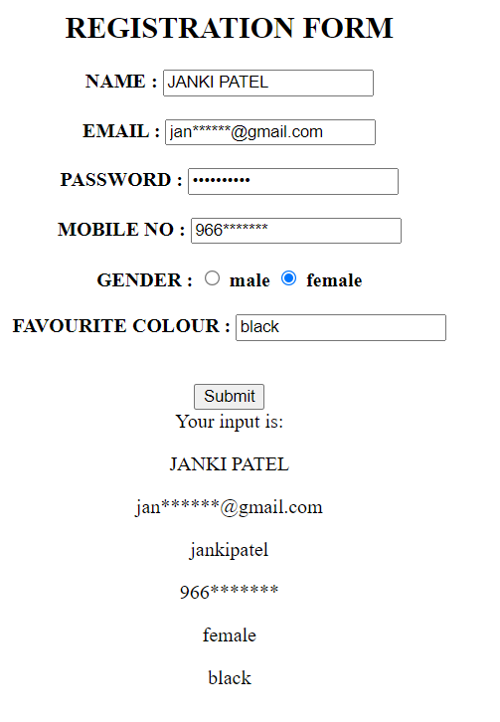

**PRACTICAL – 12**

**AIM:** **Write a JavaScript code to rotate images after a specific time interval**

<!DOCTYPE html>

<html lang="en">

<head>

<meta charset="UTF-8">

<meta name="viewport" content="width=device-width, initial-scale=1.0">

<title>Image Rotation</title>

<style>

#image {

transition: transform 1s ease;

height: 48%;

width: 48%;

margin-top: 9%;

margin-left: 25%;

/* border-radius: 100%; */

}

</style>

</head>

<body>

<img id="image" src="2.jpg" alt="Image">

<script>

const image = document.getElementById('image');

let rotationAngle = 0;

function rotateImage() {

rotationAngle += 45; // Rotate by 45 degrees (you can change this value)

image.style.transform = `rotate(${rotationAngle}deg)`;

}

setInterval(rotateImage, 2000); // Rotate every 2 seconds (you can change this interval)

</script>

</body>

</html>

**OUTPUT:**



**PRACTICAL – 13**

**AIM: Create an XML file and XML Schema to store student information like Enrolment Number, Name, Mobile Number and Email Id.**

<?xml version="1.0" encoding="UTF-8"?>

<?xml-stylesheet type='text/xsl' href='cgpa.xsl"?>

<class>

<student>

<name> ABC </name>

<id> 001 </id>

<branch> IT </branch>

<cgpa>9</cgpa>

</student>

<student>

<name> PQR </name>

<id>004 </id>

<branch> Computer </branch>

<cgpa> 7 </cgpa>

</student>

<student>

<name> XYZ </name>

<id>006 </id>

<branch> IT </branch>

<cgpa> 10</cgpa>

</student>

</class>

**OUTPUT:**

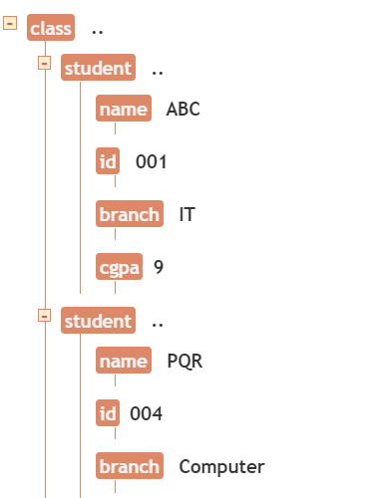

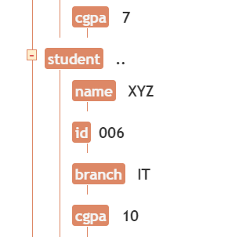

**PRACTICAL – 14**

**AIM: Create Document Type Definition (DTD) for above XML File.**

<?xml version="1.0" encoding="UTF-8"?>

<xsl:stylesheet version="1.0" xmlns:xsl="https://www.w3.org/1999/XSL/Transform"> <xsl:template match="/">

<html>

<body>

<h2>Student list in descending order of their CGPA.</h2>

<table border="1">

<tr bgcolor="lightblue">

<th>ID</th>

<th>Name</th>

<th>Branch</th>

<th>CGPA</th>

</tr>

<xsl:for-each select="class/student">

<xsl:sort select="cgpa" order="descending" data-type="number"/>

<tr>

<td><xsl:value-of select="id"/></td>

<td><xsl:value-of select="name"/></td>

<td><xsl:value-of select="branch"/></td> <td><xsl:value-of select="cgpa"/></td>

</tr>

</xsl:for-each>

</table>

</body>

</html>

</xsl:template>

</xsl:stylesheet>

**OUTPUT:**

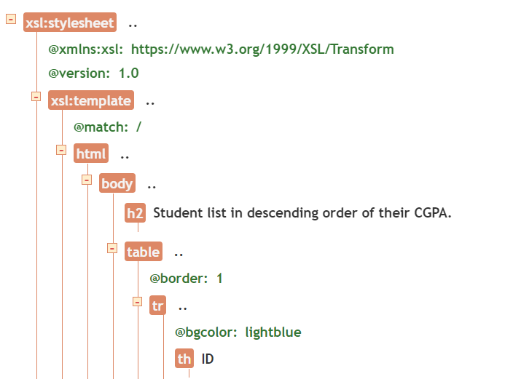

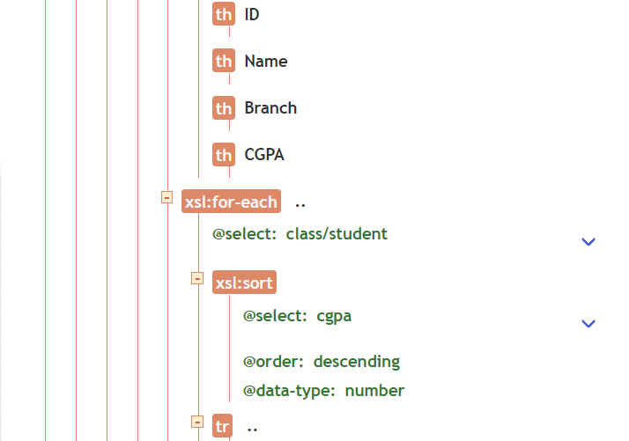

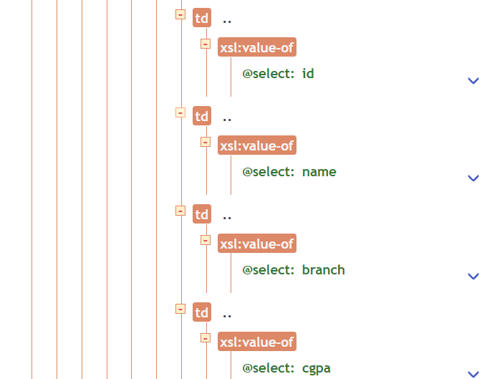

**PRACTICAL – 15**

**AIM: Write a php program to check if number is prime or not**

<html>

<head>

<title>PHP Test</title>

</head>

<body>

<?php

function isPrime($number) {

if ($number < 2) {

return false;

}

for ($i = 2; $i * $i <= $number; $i++) {

if ($number % $i == 0) {

return false; // Check for divisibility by numbers from 2 to the square of the number

}

}

return true;

}

$number = 17; // Change this to the number you want to check

if (isPrime($number)) {

echo $number . " is a prime number.";

} else {

echo $number . " is not a prime number.";

}

?>

<script src="https://replit.com/public/js/replit-badge-v2.js" theme="dark" position="bottom-right"></script>

</body>

</html>

**OUTPUT:**

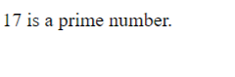

**PRACTICAL – 16**

**AIM:** **Create HTML page that contain textbox, submit / reset button. Write php program to display this information and also store into text file.**

<!DOCTYPE html>

<html>

<head>

<title>Form Example</title>

</head>

<body>

<h1>Simple Form</h1>

<form action="process.php" method="post">

<label for="name">Name:</label>

<input type="text" id="name" name="name" required><br><br>

<input type="submit" value="Submit">

<input type="reset" value="Reset">

</form>

</body>

</html>

<?php

if ($_SERVER["REQUEST_METHOD"] == "POST") {

$name = $_POST["name"];

}

// Open a text file for writing (you can specify the path) $file = fopen("data.txt", "a"); // "a" means append to the file

if ($file) {

fwrite($file, "Name: $name\n"); // Write the data to the file

// Close the file

fclose($file);

// Display a success message

echo "Data has been successfully stored in 'data.txt'."; } else {

}

// Display an error message if the file couldn't be opened echo "Error: Unable to open the file for writing.";

?>

**OUTPUT:**

